1. Make a copy of the Excel File so that you have a backup in case something goes wrong.
2. Open the Excel document.
3. Click on the Data Tab and click on Existing Connections.

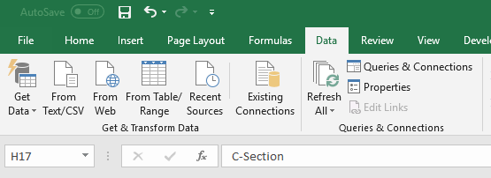

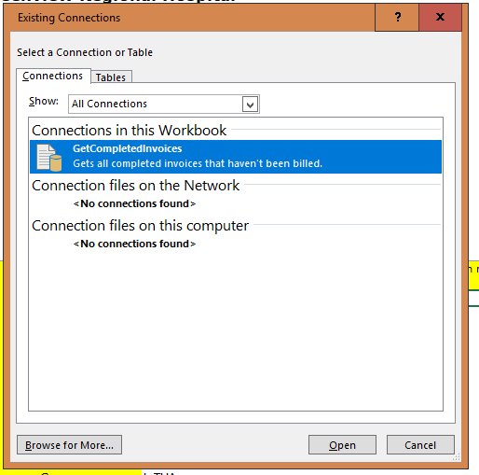

1. Right-click on GetCompletedInvoices and choose Edit Connection Properties.

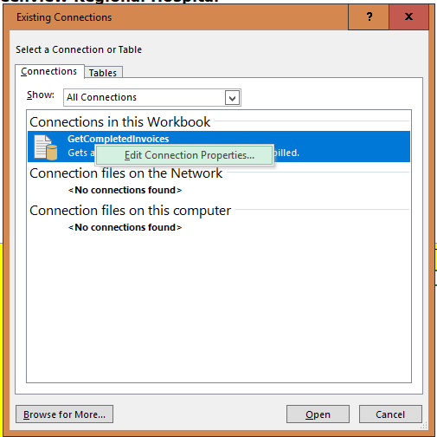

1. Click on the Definition tab and then click on Edit Query. This will cause a browser window to popup. Sign in with your user credentials.

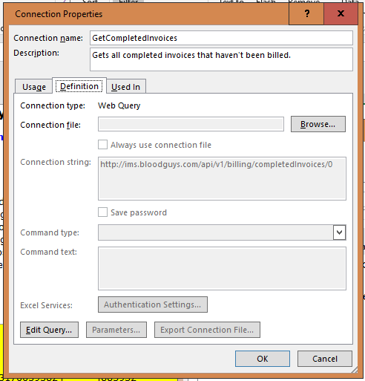

1. Click the Yellow Arrow near the top of the page. It should turn to a checkmark. Click Import.

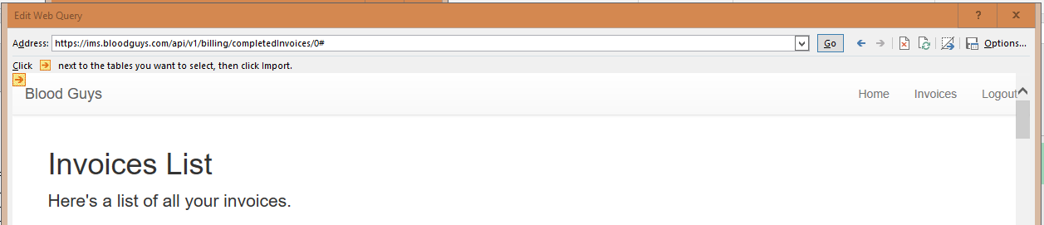

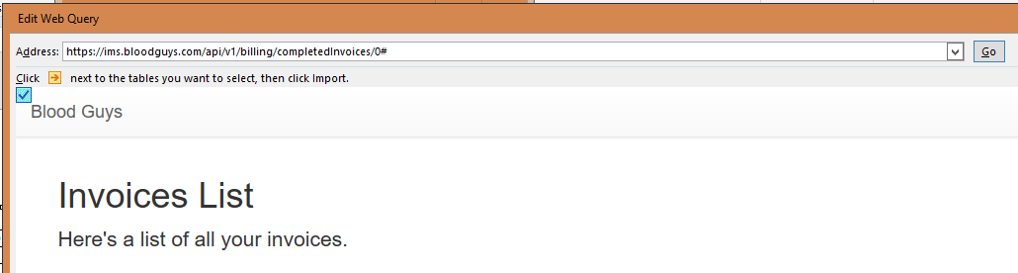

1. Click Ok.